Cerebrovascular reactivity mapping without hypercapnic challenge in patients with carotid artery stenosis
Mapeamento da reatividade cerebrovascular sem desafio de hipercapnia em pacientes com estenose da artéria carótida

Kaio F. Secchinato¹, Pedro H. R. Silva¹, Ana P. A. Camargo², Octavio M. Pontes-Neto², Renata F. Leoni¹

¹Inbrain, Departamento de Física, USP – Ribeirão Preto, Brasil.
²Departamento de Neurociências e Ciências do Comportamento, USP – Ribeirão Preto, Brasil.

Abstract
Vascular reactivity represents the ability of the vascular smooth muscle to dilate or contract in response to changes in metabolic demand or vasoactive stimulus. More specifically, the cerebrovascular reactivity (CVR) has raised interest in several studies that point to its potential to predict stroke risk in patients with cerebrovascular disease. CVR mapping is typically performed using carbon dioxide (CO₂) inhalation, breath-holding, or acetazolamide injection as vasoactive challenges, while magnetic resonance imaging (MRI) based on the blood oxygenation level-dependent (BOLD) contrast is acquired. However, such challenges of hypercapnia depend on additional equipment and cooperation of the subjects, limiting their applications, especially in elderly patients. Therefore, the objective of the present study was to map the CVR using resting-state MRI-BOLD, with no hypercapnic challenge, considering the variations in BOLD signal associated with variations in the arterial partial pressure of CO₂. The CVR maps obtained with resting data showed a high correlation with those obtained by the conventional experiment with CO₂ inhalation (r > 0.70). In addition, the CVR changes observed for the patients were consistent with their clinical reports. These results show that the mapping of CVR obtained with resting-state data may become a useful alternative in the detection of perfusion changes in clinical applications when the hypercapnic challenge is not feasible.
Keywords: Cerebrovascular disease; resting state; magnetic resonance imaging; cerebral vasoreactivity.

Resumo
A reatividade vascular representa a habilidade da musculatura lisa vascular de dilatar-se ou contrair-se em resposta às alterações de demanda metabólica ou estímulo vasoativo. Mais especificamente, a reatividade vascular cerebral (do inglês, CVR) tem despertado o interesse de diversos estudos que apontam seu potencial para prever o risco de acidente vascular cerebral (AVC) em pacientes com doenças cerebrovasculares. O mapeamento da CVR é tipicamente feito utilizando inalação de gás carbônico (CO₂), pausa respiratória, ou injeção de acetazolamida, como desafios vaso reativos, enquanto são feitas aquisições de imagens por ressonância magnética (IRM) baseadas no contraste dependente do nível de oxigenação do sangue (BOLD). No entanto, esses desafios de hipercapnia dependem de equipamentos adicionais e cooperação dos pacientes, limitando suas aplicações, principalmente quando se trata de pacientes idosos. Portanto, o objetivo do presente estudo foi mapear a CVR utilizando IRM-BOLD adquiridas em repouso, sem desafio hipercápnico, considerando que há variações no sinal BOLD associadas às variações da pressão parcial de CO₂ no sangue. Os mapas de CVR obtidos com dados de repouso apresentaram alta correlação com aqueles obtidos pelo experimento convencional com inalação de CO₂ (r > 0,70). Além disso, as alterações de CVR observadas para os pacientes foram consistentes com seus laudos clínicos. Esses resultados mostram que o mapeamento de CVR obtido com dados em estado de repouso pode ser uma alternativa útil na detecção de alterações perfusionais em aplicações clínicas quando o desafio hipercápnico não é possível de ser realizado.
Palavras-chave: Doença cerebrovascular; estado de repouso; imagem por ressonância magnética; vasorreatividade cerebral.

1. Introduction
One of the main features of cerebral blood circulation is an effective mechanism that seeks to keep blood flow within a safe range to protect brain tissue in situations of functional demands. In disturbing situations, such as changes in blood pressure (1) or changes in blood pH (2), the brain needs to establish an optimal level of blood perfusion, also known as brain autoregulation, or cerebrovascular reactivity (CVR), which may be affected by cerebrovascular diseases, arousing interest in several fields of study.
CVR represents the ability of the vascular smooth muscle to dilate or contract in response to changes in metabolic demand or a vasoactive stimulus. Briefly, changes in blood plasma CO₂ concentration alter the concentration of H⁺ ions and, consequently, the blood pH (3). These changes cause alterations in the caliber of the cerebral arteries and thus the speed of blood flow.
Previous studies have evaluated different magnetic resonance imaging (MRI) protocols based on the blood oxygenation level-dependent contrast (BOLD) to assess CVR in combination with breath-holding (4), acetazolamide injection (5) or CO₂ inhalation (6). Others have explored the clinical potential of BOLD-MRI and vasoactive stimuli, and have shown its ability to differentiate between normal and impaired CVR in arterial stenosis (7), stroke, small vessel disease (8), neurovascular coupling in brain tumors (9), hypertension (1), Alzheimer's disease (10), and epilepsy (11). In patients whose clinical evaluation still leaves doubts about the correct diagnosis or best management, altered CVR may be a helpful image marker.
However, there are some difficulties in obtaining CVR with this conventional methodology: (i) the need for an experimental apparatus compatible with the MR environment for the CO₂ inhalation challenge; (ii) patient cooperation during breath-holding. In both cases, there is greater difficulty in elderly patients and/or in severe conditions. Thus, a new CVR mapping approach without a vasoactive challenge was recently proposed (12). This approach uses the natural variation in respiration over time and, therefore in partial blood pressure of CO₂ as an intrinsic vasoactive stimulus. However, its performance has only been evaluated in healthy young people and patients with Moyamoya disease. Therefore, the present study aimed to map CVR using resting-state BOLD-MRI, without hypercapnic challenge, in healthy elderly and patients with carotid artery stenosis.

2. Materials and Methods
2.1 Subjects
Five patients (70 ± 3 years old; 2 men, 3 women) and five elderly controls (65 ± 3 years; 3 men, 2 women) participated in this study approved by the Ethics Committee of the Hospital das Clínicas da Faculdade de Medicina de Ribeirão Preto (HCFMRP), where images were acquired. Table 1 shows the patient demographics as well as the percentages of right and left internal carotid artery (ICA) stenosis.

2.2 MR system
Images were acquired on a 3T MR scanner (Philips Medical Systems, The Netherlands) using a 32-channel receiving coil. For anatomical reference, structural images were acquired using a T1-weighted gradient-echo (GRE) sequence with the following parameters: TR = 6.7 ms, TE = 3.1 ms, flip angle = 8°, matrix = 256 x 256, number of slices = 180, slice thickness = 1 mm, voxel size = 1 x 1 x 1 mm³.
Resting-state BOLD images were acquired using an echo planar readout (EPI), GRE sequence and the following parameters: TR = 2000 ms, TE = 30 ms, matrix = 128 x 128, FOV = 230 x 230 mm², number of slices = 31, slice thickness = 4 mm, 200 volumes. BOLD images during CO₂ inhalation were acquired using an EPI GRE sequence with the following parameters: TR = 1000 ms, TE = 1000 ms, matrix = 128 x 128, FOV = 230 x 230 mm², number of slices = 20, slice thickness = 4 mm, 250 volumes. The block-designed paradigm consisted of five blocks of CO₂ inhalation (duration: 14 s each), intercalated by six blocks of normal breathing (duration: 30 s each). The experimental apparatus was previously described (13).

Table 1 – Patients’ demographics.
Patient | Age | Gender | Right ICA stenosis (%) | Left ICA stenosis (%)
p1 | 81 | F | <30 | >70
p2 | 65 | F | 50 | >70
p3 | 65 | M | >70 | 50
p4 | 71 | F | >70 | -
p5 | 68 | M | >70 | -
ICA: internal carotid artery. F: female, M: male.

2.3 MRI preprocessing
Images were preprocessed using the Statistical Parametric Mapping (SPM) software and own routines written in MATLAB (MathWorks Natick, Massachusetts). The steps followed for BOLD images were: (i) reorientation of images with the anterior commissure of each individual as reference; (ii) time correction between slices as they were acquired sequentially, causing a time lag between the slices that constitute a volume; (iii) head-movement correction between volumes; (iv) co-registration with structural images; (v) normalization to the Montreal Neurological Institute (MNI) standard space, and (vi) spatial smoothing with a 6-mm Gaussian filter.

2.4 CVR mapping
For the hypercapnic CVR (HC-CVR) mapping of each participant, a linear regression analysis was performed between the block predictor (independent variable), considering CO₂ inhalation and regular room-air respiration periods, with the BOLD time series (dependent variable) of all voxels of the image. Since there is a delay between gas inhalation and hemodynamic response, the predictor was corrected for this delay. This correction was done considering the delay in the global BOLD signal. Each linear regression index was then normalized to the average value calculated for the whole brain.
For the resting-state CVR (RS-CVR) mapping of each participant, the BOLD signal was first filtered to different frequency bands (0 - 0.01 Hz; 0.01 - 0.02 Hz; 0.02 – 0.04 Hz; 0.04 - 0.08 Hz; 0.08 - 0.20 Hz) (12). Then the mean global signal (considering the whole brain) was obtained for each frequency band and used as a predictor (independent variable) in the linear regression analysis. The time series of all voxels, also filtered for the same frequency bands, were used as dependent variables. The CVR value was obtained by normalizing each estimated index to the average value calculated for the whole brain.
The CVR values obtained from the resting-state signal, filtered for different frequency bands, were correlated with those obtained for CO₂ inhalation, using Pearson’s correlation.

3. Results
Figure 1 shows the correlation coefficients between RS-CVR values obtained from signal filtering with different frequency bands, with those obtained for CO₂ inhalation (HC-CVR). The correlation was significantly stronger when the time series were filtered at 0.02-0.04 Hz, compared to the other frequency bands (p <0.05), as shown in figure 1. It suggests that the resting-state BOLD signal component at a frequency band of 0.02-0.04 Hz provides the best estimate of CVR.

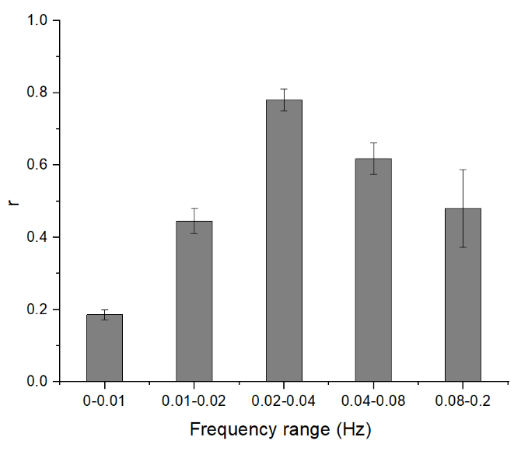
Figure 1 - Pearson's correlation coefficients between cerebrovascular reactivity values obtained from the resting-state signal (RS-CVR), filtered for different frequency bands, with those obtained during CO₂ inhalation (HC-CVR). Single-factor ANOVA with multiple comparisons showed significant differences between all frequency bands analyzed (p < 0.01) except for 0.01-0.02 Hz with 0.08-0.02 Hz (p = 0.15).

In addition, RS-CVR maps for band frequency of 0.02-0.04 Hz, showed good contrast between gray matter and white matter, and spatial agreement with the HC-CVR maps. Figure 2 shows the results for two representative subjects, healthy control, and a patient. Pearson’s correlation coefficients between RS-CVR and HC-CVR values were higher than 0.70 for all participants.
Finally, RS-CVR maps of patients showed deficits mainly in brain regions irrigated by the anterior and middle cerebral arteries, branches of the ICA, in the hemisphere ipsilateral to the stenosis of higher degree.
4. Discussion
In the present study, we showed that the CVR maps obtained by resting-state BOLD-MRI have a high correlation with CVR maps obtained by the conventional method, based on CO₂ inhalation. It confirms that the BOLD signal obtained at rest has information related to changes in the partial pressure of CO₂ in the blood, mainly in the frequency band of 0.02-0.04 Hz.
As Lu and colleagues showed for healthy young people and patients with Moyamoya disease (12), we demonstrated that the proposed methodology without hypercapnia challenge can be used in elderly people and patients with internal carotid artery stenosis. As expected, reduced RS-CVR was observed in brain areas irrigated by the anterior and middle cerebral arteries in the hemisphere ipsilateral to the stenosis (14).
However, this study has some limitations. First, the CVR quantification in relative units in contrast to the conventional methodology that provides CVR in absolute units or %/mmHg of EtCO₂ (end-tidal CO₂). Also, we had shown empirically that there was a more significant correlation between the CVR maps when the signal was filtered in the 0.02-0.04 Hz frequency band. However, there may be a contribution from sources other than CO₂ partial pressure, such as changes in neural activation in different states of attention during acquisition, heart rate and subject movement (15). These influences should be considered in future work.

5. Conclusion
We showed the applicability of a new methodology to map cerebrovascular reactivity without the need for gas inhalation or breath-holding in healthy elderly, and patients with atherosclerotic internal carotid disease. Our results showed a high correlation of resting-state CVR values with the hypercapnia-based CVR values, which is the conventional method for such evaluation. These results confirm that the resting-state CVR mapping may become a useful alternative for detecting perfusion deficits in clinical applications when hypercapnia challenge is not feasible.

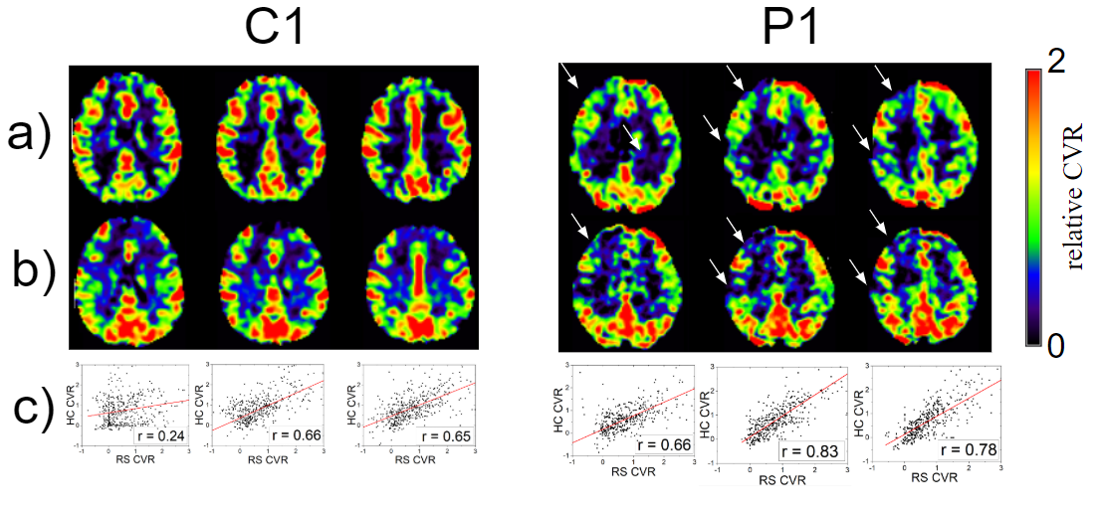
Figure 2 - Comparison between the two methodologies for one elderly control (c1) and one patient (p1). a) CVR maps obtained by the conventional method with CO₂ inhalation. b) CVR maps obtained by the resting-state methodology. White arrows indicate regions with reduced CVR. c) Correlation between the CVR values obtained by each methodology (down-sampled by 5x5x5 voxels).

6. References
1. Leoni RF. Avaliação da perfusão sangüínea cerebral em modelos animais de hipertensão utilizando Arterial Spin Labeling. 2011;
2. Liu P, Vis JB De, Lu H. NeuroImage Cerebrovascular reactivity ( CVR ) MRI with CO2 challenge : A technical review. Neuroimage [Internet]. 2018;(March):1–12. Available from: https://doi.org/10.1016/j.neuroimage.2018.03.047
3. Yoon SH, Zuccarello M, Rapoport RM. Reversal of hypercapnia induces endothelin-dependent constriction of basilar artery in rabbits with acute metabolic alkalosis. Gen Pharmacol Vasc Syst. 2000;
4. Magon S, Basso G, Farace P, Ricciardi GK, Beltramello A, Sbarbati A. Reproducibility of BOLD signal change induced by breath holding. Neuroimage. 2009;
5. Settakis G, Molnár C, Kerényi L, Kollár J, Legemate D, Csiba L, et al. Acetazolamide as a vasodilatory stimulus in cerebrovascular diseases and in conditions affecting the cerebral vasculature. European Journal of Neurology. 2003.
6. Lu H, Liu P, Yezhuvath U, Cheng Y, Marshall O, Ge Y. MRI mapping of cerebrovascular reactivity via gas inhalation challenges. J Vis Exp. 2014;
7. Leoni RF, Mazzetto-Betti KC, Silva AC, dos Santos AC, de Araujo DB, Leite JP, et al. Assessing Cerebrovascular Reactivity in Carotid Steno-Occlusive Disease Using MRI BOLD and ASL Techniques. Radiol Res Pract. 2012;2012:1–10.
8. Greenberg SM. Small vessels, big problems. New England Journal of Medicine. 2006.
9. Fierstra J, van Niftrik B, Piccirelli M, Burkhardt JK, Pangalu A, Kocian R, et al. Altered intraoperative cerebrovascular reactivity in brain areas of high-grade glioma recurrence. Magn Reson Imaging. 2016;
10. Alwatban M, Murman DL, Bashford G. Cerebrovascular Reactivity Impairment in Preclinical Alzheimer’s Disease. J Neuroimaging. 2019;
11. Pastorello BF. Em busca da região epileptogênica em pacientes com epilepsia do lobo temporal : métodos alternativos baseados em fMRI e EEG-fMRI Ribeirão Preto – SP Em busca da região epileptogênica em pacientes com epilepsia do lobo temporal : métodos alternativos basea. 2011;
12. Liu P, Li Y, Pinho M, Park DC, Welch BG, Lu H. Cerebrovascular reactivity mapping without gas challenges. Neuroimage. 2017;
13. Leoni RF, Oliveira IAF, Pontes-Neto OM, Santos AC, Leite JP. Cerebral blood flow and vasoreactivity in aging: An arterial spin labeling study. Brazilian J Med Biol Res. 2017;
14. Taneja K, Lu H, Welch BG, Thomas BP, Pinho M, Lin D, et al. Evaluation of cerebrovascular reserve in patients with cerebrovascular diseases using resting-state MRI: A feasibility study. Magn Reson Imaging. 2019;
15. Tong Y, Frederick B de B. Tracking cerebral blood flow in BOLD fMRI using recursively generated regressors. Hum Brain Mapp. 2014;

Contato:
Kaio Felippe Secchinato
Departamento de Física, FFCLRP, Universidade de São Paulo
Avenida Bandeirantes, 3900. Ribeirão Preto, Brasil
E-mail: kaio.secchinato@usp.br

Pedro Henrique Rodrigues da Silva
Departamento de Física, FFCLRP, Universidade de São Paulo
Avenida Bandeirantes, 3900. Ribeirão Preto, Brasil
E-mail: pedrojoanabrit@gmail.com

Ana Paula Afonso Camargo
Departamento de Neurociência e Ciências do Comportamento, FMRP, Universidade de São Paulo
Rua Ten. Catão Roxo, 2650. Hospital das clínicas 4º andar, sala 438. Ribeirão Preto, Brasil
E-mail: anapaula.camargo@usp.br

Octavio Marques Pontes Neto
Departamento de Neurociência e Ciências do Comportamento, FMRP, Universidade de São Paulo
Rua Ten. Catão Roxo, 2650. Hospital das clínicas 4º andar, sala 438. Ribeirão Preto, Brasil
E-mail: ompneto@gmail.com

Renata Ferranti Leoni
Departamento de Física, FFCLRP, Universidade de São Paulo
Avenida Bandeirantes, 3900. Ribeirão Preto, Brasil
E-mail: leonirf@usp.br

